Heart Stroke Prediction using Machine Learning Algorithms
Sonu Rajendran
Department of Computer Science
Mumbai University
Mumbai, India
sonurajendran2@gmail.com

Abstract— The primary purpose of this project is to predict coronary heart strokes. Heart strokes are on the rise globally, including among children and teens. In recent times, heart stroke prediction has become one of the most complex tasks in the medical field. Currently, approximately one person dies every minute due to a heart stroke. Unfortunately, detecting such conditions in individuals is a challenging task. Given the complexity of heart stroke prediction, there is a need to automate the prediction process to mitigate the associated risks and alert patients well in advance. Handling such complex tasks can be achieved by utilizing historical and reliable datasets. Heart stroke prediction is carried out using a dataset within the chosen model. Automation for this project is achieved through various data mining approaches. Some of the methods used in this project include decision trees, Logistic regression, the KNN algorithm, SVM classifier, and Random Forest machine learning algorithms. Based on factors such as age, gender, average glucose level, smoking status, body mass index, employment type, living conditions, marital status, hypertension, and history of coronary heart disease, these parameters forecast the likelihood of a person having a stroke. In the end, after all the tests, we found that the Random Forest algorithm achieved an accuracy of 93.84%, and thus the algorithm was chosen to integrate with the application.
Keywords – Machine learning, Heart stroke, KNN, Random forest, Decision tree, SVM, Logistic regresssion, predict.

Introduction
Cardiovascular diseases (CVDs) are one of the leading causes of mortality globally, accounting for 32 percent of all deaths and affecting 17.9 million people worldwide. Among these, the two most significant CVDs are coronary heart attacks and strokes, which together account for 85 percent of all cases. A heart attack occurs when oxygen or blood flow to the heart muscle is interrupted, while a stroke is caused by a blockage in the artery that supplies blood to the brain. Although these diseases are serious, the risk factors that contribute to them are very similar. These factors include an unhealthy diet, smoking, diabetes, a sedentary lifestyle, excessive alcohol consumption, high blood pressure, and family history. Detecting a heart attack and seeking medical attention as soon as possible not only increases the chances of survival but also helps prevent future heart issues.
Machine learning has emerged as one of the most challenging fields in modern technology. It is a form of artificial intelligence where models can analyze data, identify patterns, and make predictions with minimal human intervention. Various machine learning techniques can be applied to predict heart stroke in individuals. Data mining techniques involve extracting valuable and hidden information from large datasets, and machine learning, a subfield of data mining, effectively handles well-formatted large-scale datasets. In the medical field, machine learning can be used for analysis, detection, and prediction of various diseases.
The primary aim of this project is to provide doctors with a tool to predict heart strokes as early as possible, helping to administer effective treatment and avoid severe consequences. Machine learning plays a crucial role in identifying hidden patterns in data, which can then be analyzed to predict heart strokes. Based on input characteristics obtained from the dataset used to train the model, the proposed system predicts heart strokes in individuals using a variety of machine learning methods, such as Random Forests and K-Nearest Neighbors.

- LITERATURE REVIEW
Heart disease kills many people, and people who smoke are more likely to develop heart disease. Many previous studies have used machine learning-based methods to predict heart attacks. Chen et al. Heart attack prediction guide. They used data from 82 stroke patients for analysis using two artificial neural network (ANN) models to predict accuracy and achieved 79% and 95% accuracy, respectively. Zhong et al. Cardiology studies have been conducted to predict mortality in stroke patients. A total of 15,099 patients were included in this study for cardiac diagnosis. They use deep neural network technology to analyze heartbeat. The authors used PCA to extract medical history and predict heart attacks. Govindarajan et al. collected data from 507 patients to conduct a study combining text extraction and machine learning to classify heart disease. Their study used various machine learning (ML) algorithms for ANN training, with the SGD algorithm achieving the highest result of 95%. Amini et al. A study found that there were determinants of arterial performance in 807 healthy and diseased participants, 50 of whom had stroke, diabetes, heart disease, smoking tobacco, hyperlipidemia, and alcohol consumption. Excludes dangerous situations. They use the c4.5 decision tree algorithm (95% accuracy) and the nearest neighbor method (94% accuracy). Shin et al. conducted research on AI-assisted heart rate prediction. Their study used the Cardiovascular Health Study (CHS) dataset to predict stroke. For main content analysis, features were extracted using the decision tree method. They used a distributed neural network approach to build the model. The model achieved 97% accuracy.
Cheng et al. published a report on the evaluation of heart failure. In their analysis using data from 82 stroke patients, two ANN models were used to find the accuracy of 79% and 95% respectively. Conducted a study to predict the mortality of stroke patients. In their study, they used 15,099 patients to analyze the incidence of heart disease. They use deep neural network approach to diagnose heart disease. The authors used PCA to extract clinical history data and predict cardiovascular disease. The area under the curve (AUC) value is 83%. Cene et al. conducted a study on automatic detection of heart disease at early stage. The main goal of their research is to develop a system for the first heart treatment using CNNs. They collected 256 images and tested the CNN model. They improve the image collection by using data stretching methods to eliminate the regions where heart diseases do not occur in body images. CNN methods gave 90% accuracy. After reviewing the above information, the main idea behind this proposal is to create an understanding of heart rate estimation.

- PROBLEM FORMULATION
- Data Sources
In this project, we used the heart disease dataset provided by Kaggle for analysis. This file contains a total of 12 features. This data was used to train and evaluate the model. Our dataset contains a total of 5110 rows and 12 columns. The data is not perfectly symmetrically distributed across all groups, but it is well distributed across other groups. In fact, collecting parallel data is quite difficult. There are a total of 12 features in this file. Table 1 summarizes this.
- Classifiers
I used Random Forest Classifier, Logistic Regression Classifier, KNN Classifier, Support Vector Machine(SVM) Classifier and the Decision Tree Classifier from sklearn toolkit.
- Random Forest: Random Forest is based on ensemble learning, where multiple decision trees are built using different subsets of the training data (using bootstrapping) and features (using random feature selection). Each tree makes a prediction, and the final prediction is the majority vote (in classification) or average (in regression) of all the trees.
It reduces overfitting, which is a common problem with individual decision trees, by averaging multiple trees. The random selection of features at each split also increases diversity among the trees, improving generalization to unseen data.
- K-Nearest Neighbors (KNN): KNN is a lazy learning algorithm that doesn't explicitly learn a model during training. Instead, it stores the entire training dataset and makes predictions by looking at the k closest points (neighbors) in the feature space during testing. A new point is classified by the majority label of these neighbors.
The proximity between data points is measured using distance metrics (e.g., Euclidean distance), and the classification is made based on the most common label among the nearest neighbors. It’s effective in scenarios where similar data points tend to have the same class label.
- Support Vector Machine (SVM): SVM works by finding the hyperplane (in 2D, this is a line; in higher dimensions, it's a plane) that best separates the classes with the largest margin. The margin is the distance between the hyperplane and the closest data points (called support vectors) from each class.
SVM focuses on maximizing the margin, as a larger margin is thought to lead to better generalization. For data that isnât linearly separable, SVM uses kernel functions (like the RBF or polynomial kernel) to transform the data into a higher-dimensional space where a linear separator can be found.
- Logistic Regression: Logistic Regression estimates the probability of a binary outcome (e.g., stroke or no stroke) based on one or more input features. It applies a logistic function (sigmoid curve) to a linear combination of the input features to output a probability.
The logistic function maps any real-valued number into the range [0, 1], which can be interpreted as a probability. The model is trained by maximizing the likelihood of the observed data using an optimization algorithm (e.g., gradient descent). Logistic Regression is effective when the relationship between features and the outcome is approximately linear.
- Decision Tree: A Decision Tree splits the data recursively based on the value of a chosen feature that best separates the classes (using metrics like Gini impurity or information gain). At each node, the data is divided into branches based on this feature, and the process continues until the leaves contain homogeneous data points (i.e., belonging to a single class).
The tree is built top-down by selecting the best feature at each step that minimizes classification error. The splitting continues until certain stopping criteria are met (e.g., maximum depth, minimum samples in a node). Decision Trees can easily overfit, but they are interpretable and provide a clear path of decision-making based on the features.

METHODOLGY
- Import Data: Importing the dataset for data pre-processing which is in csv format. The dataset consists of 12 parameters and that parameters are id, age, gender, hypertension, worktype, residence type, heart disease, avg level of glucose, body mass index (bmi), marital status, smoking status, and stroke. Importing the required libraries i.e. pandas, Numpy, Matplotlib, Seaborn, and warnings libraries. Import the CSV data as pandas Dataframe. Explore the shape, size, describe functions. Statsitical Inference.

- Data Mining:

Exploratory data analysis: The dataset contains string values which I had to integer encoding for string values. Like for example, the string ‘Male’ ‘Female’ with ‘0’ and ‘1’ and so on for other categorial features as the model will only procees the data in binary language.

- id : This attribute means person’s id. It’s numerical data.
- Age : This attribute means a person’s age. It’s numerical data.
- Gender : This attribute means a person’s gender. It’s categorical data.
- Hypertension : This attribute means that this person is hypertensive or not. It’s numerical data.
- work type : This attribute represents the person work scenario. It’s categorical data.
- residence type : This attribute represents the person living scenario. It’s categorical data.
- heart disease : This attribute means whether this person has a heart disease person or not. It’s numerical data.
- avg glucose level : This attribute means what was the level of a person’s glucose condition. It’s numerical data.
- Bmi : This attribute means body mass index of a person. It’s numerical data.
- ever married : This attribute represents a person’s married status. It’s categorical data.
- smoking Status : This attribute means a person’s smoking condition. It’s categorical data.
- Stroke : This attribute means a person previously had a stroke or not.
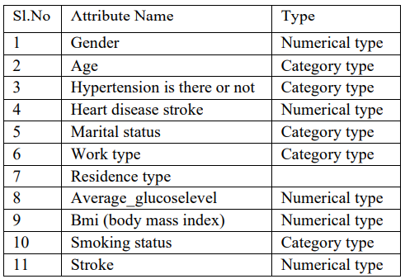

Univariate Analysis: The term univariate analysis refers to the analysis of one variable prefix “uni” means “one.” The purpose of univariate analysis is to understand the distribution of values for a single variable. It is commonly used for both categorical and numerical data.
- age, bmi,avg_glucose_level are the only continuous features.
- id is a primary key which is of no importance.
- hypertension, heart_disease, stroke are Categorical features but they are encoded.
Multivariate Analysis: It is the analysis of more than one variable.
- Check Multicolinearity in Numerical Features:
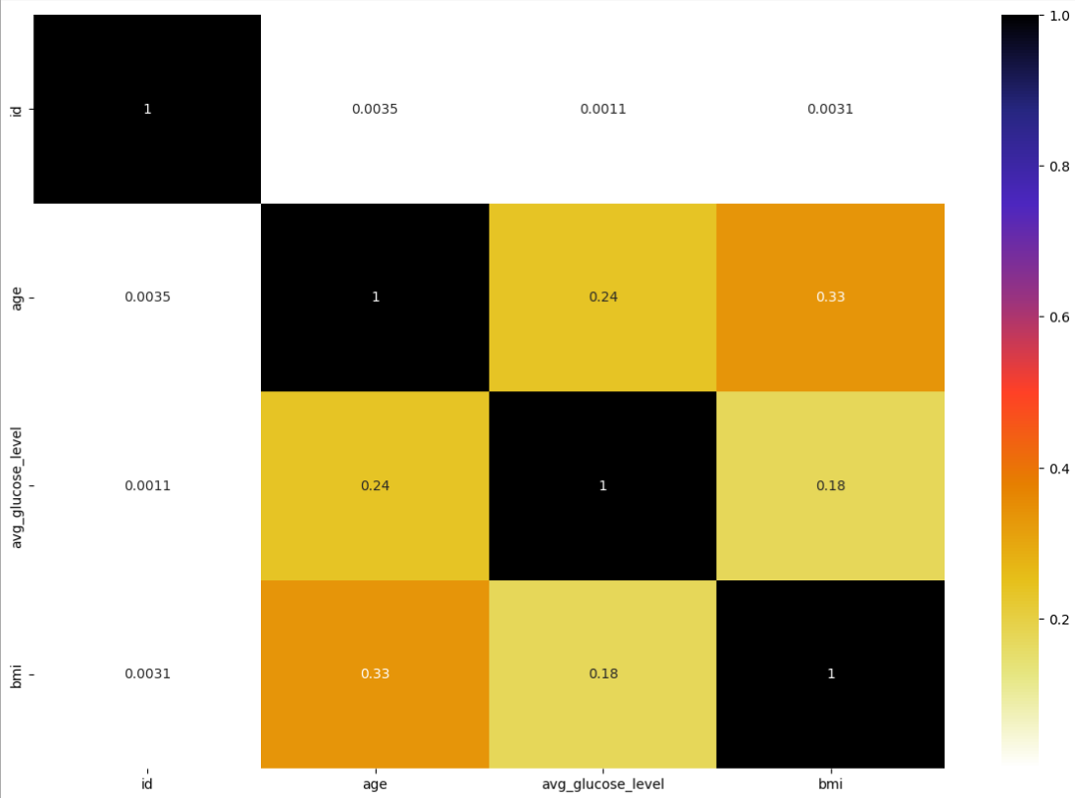
- Check Multicolinearity in Categorial Features:
A chi-squared test (also chi-square or χ2 test) is a statistical hypothesis test that is valid to perform when the test statistic is chi-squared distributed under the null hypothesis, specifically Pearson’s chi-squared test. A chi-square statistic is one way to show a relationship between two categorical variables.
Null Hypothesis (): The Feature is independent of target column (No-Correlation).
Alternative Hypothesis (): The Feature and Target column are not independent (Correlated).
Col Hypothesis Result
0 gender Fail to Reject Null Hypothesis
1 ever_married Reject Null Hypothesis
2 work_type Reject Null Hypothesis
3 Residence_type Fail to Reject Null Hypothesis
4 smoking_status Reject Null Hypothesis
5 hypertension Reject Null Hypothesis
6 heart_disease Reject Null Hypothesis
7 stroke Reject Null Hypothesis
Gender and Residence_type are independent of the target columnn.
- Fill Null Values: we should always handle the missimg values in the datset while always preparing the data The dataset had 201 rows of missing values out of the total 5110 rows in the dataset which was of the feature ‘bmi’. Filled missing values using ‘mean’ with the average count, 201 rows of null values filled with the average mean count that is 28.89.
Initial Analysis Report-
- There were missing values in the bmi.
- The ‘id’ col can be deleted as each row has unique values.
- Resident_type & Gender cols are not correlated with stroke.
- The stroke column is the target to predict.
- Visualization:
Visualising each & every feature of the dataset.
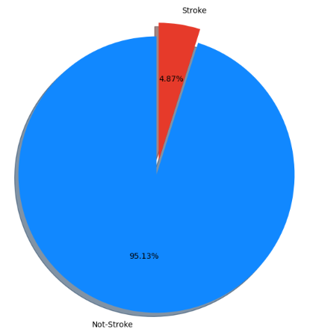
- Visualize the target fetaure-

From the chart it is clear that the Target variable is imbalanced i.e. here number of not-stroke has more count .
Do Men or Women have more chance of stroke?
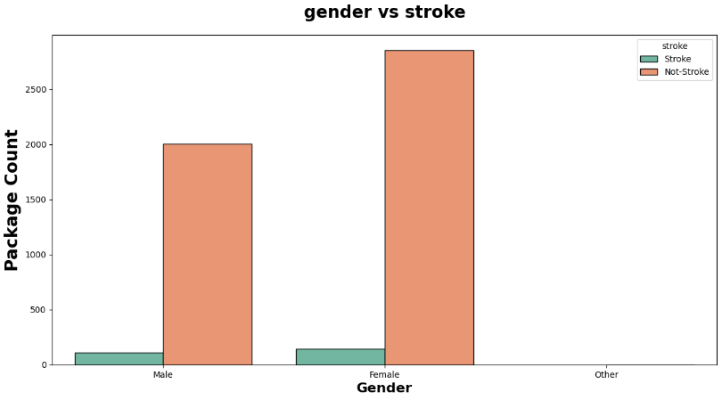
Insights:
- As per the chart there is no much difference between the stroke of male and female.
- This Feature has no impact on the Target Variable.

- Age Category Split:
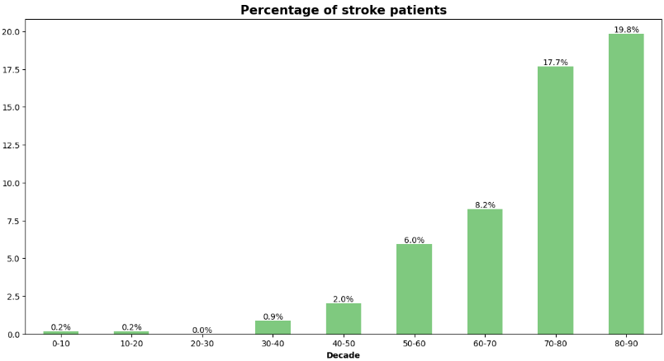
Insights:
- As per the Chart Senior age Group has the more chance of heart stroke followed by adults.
- Children and teen have least chance of the stroke because of high physical activity. As the age increases there is higher chance of heart stroke.

- Does HyperTension makes any difference:
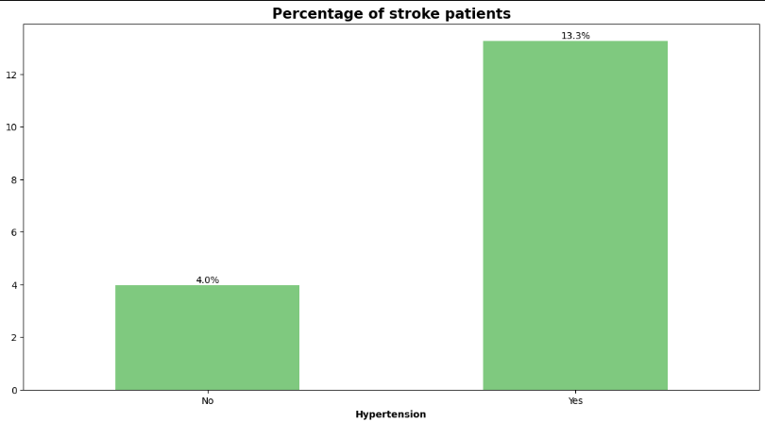
Insights:
- Even though the patients with no hypertension and having chance of stroke are high but remember the data is imbalanced
- In comparision with the number of plople in both categories patients with hypertension have more chance of stroke.

- Impact of BMI:
BMI can be divided into four categories:
Under_weight ( BMI < 18.5 )
Normal_weight ( 18.5 < BMI < 25 )
Over_weight ( 25 < BMI < 30 )
Obese ( BMI > 30 )
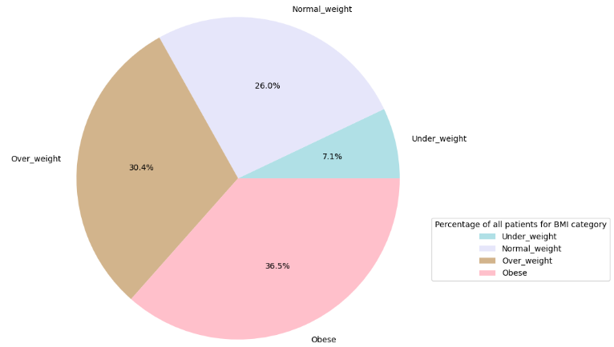
- We have most number of obese patients followed by the
Over_weight totally comprises of nearly 65% of the total patients and have least number of patients with underweight.

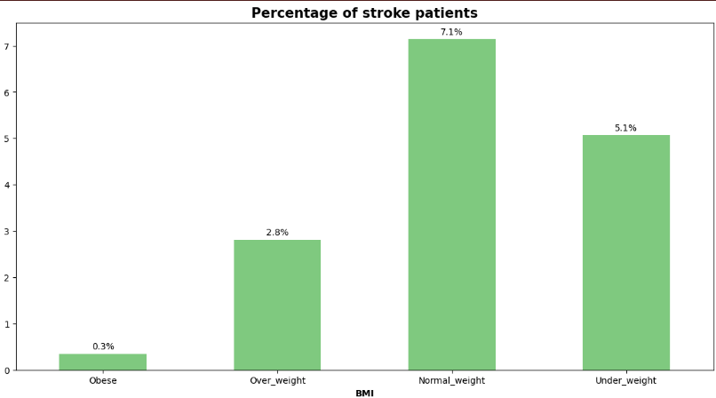
Insights:
- Obese and overweight people have more chance of stroke.

- Heart Diseases vs Stroke:
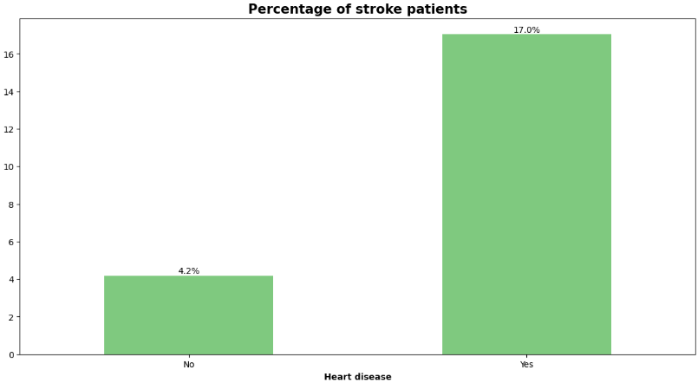
- Patients with heart disease have high chance of heart attack the the healty people.

- Does marriage has any affect on stroke:
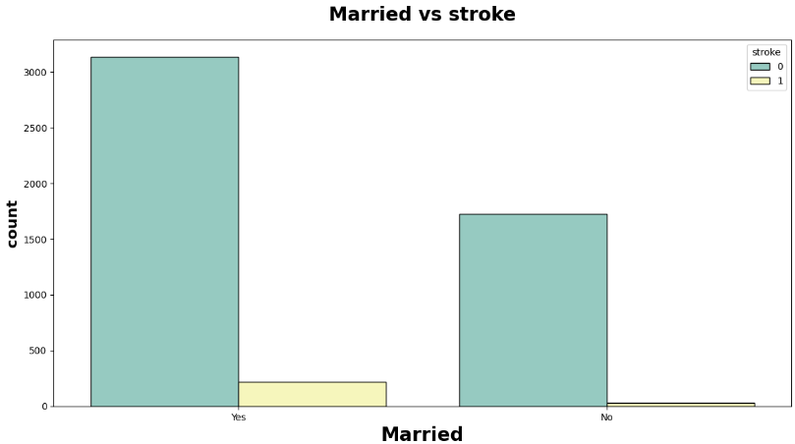
Insights:
- Surprisingly married people have more chance of stroke which doesn’t make any sense.
- It may because the married peple are aged than the unmarried and age is factor playing major role.

- Work type has any effcet on stroke?
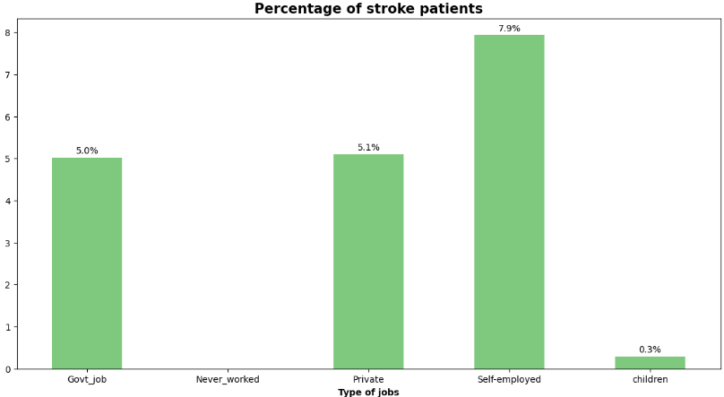
Insights:
- Self-employed patients have high chance of heart stroke.
- Government and provate job employes have nearly same chance of heart stroke.
- Unemployed and children have least or near zero chance of stroke.

- Residence type on stroke:
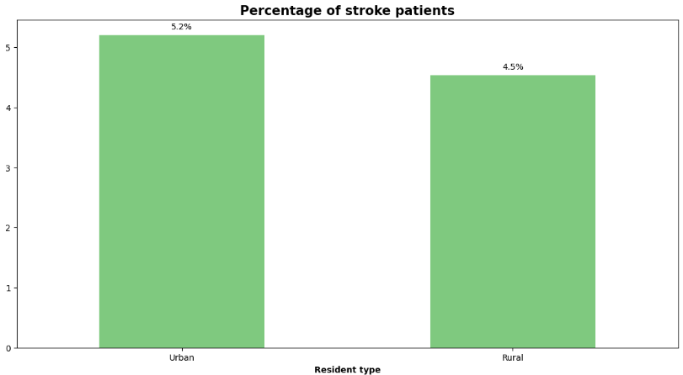
Insights:
- Urban residents silghtly edge over the rural residents here.

- Effect of glucose level on stroke:
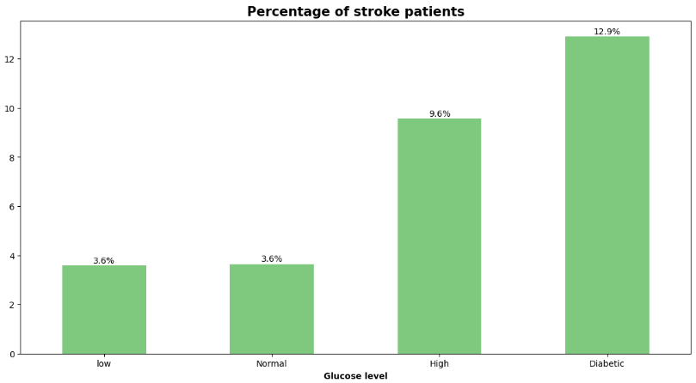
Insights:
- We can see that the patients with low or normal glucose levels have less chance of stroke.
- High chance of stroke is found in diabetic patients followed by high glucose level.

- Smoking status vs stroke:
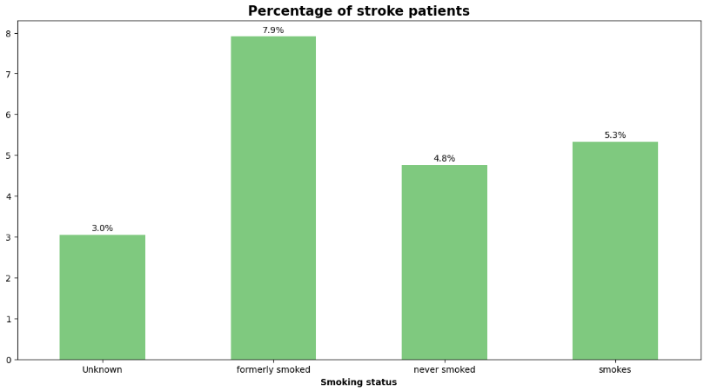
Insights:
- Formerly_smoked seems to have high chance of stroke
- Smokes and never smoked have nearly same chance
- Smoking have a long term impact and may not be seen at the beginning stages.

- Data Pre-Processing:
- Data Cleaning (Outlier Removel):
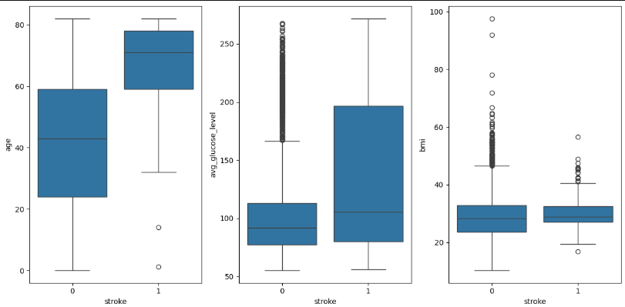
Insights:
-The stroke column is the target to predict.
-There are outliers in the avg_glucose_level, bmi columns.
-Gender and Residence_type has less or no effect on target column.
- We will keep the outliers in the glucose_level and bmi since they are reasons to decide on whether the person has a stroke or not.

- Feature Engeneering:
Types of fetaures:
- Categorial Fetaures: These are features that are data in predefined categories. There values are typically names or labels, not numeric values. Since ML models cannot handle non-numeric data, these features need to be converted to numeric values.
Num of Categorical Features : 5
['gender', 'ever_married', 'work_type', 'Residence_type', 'smoking_status']

- Numeric Features: These represent data that is quantitative and can be measured. These features include both discrete and continuous variables.
Num of Numerical Features : 6
['age', 'hypertension', 'heart_disease', 'avg_glucose_level', 'bmi', 'stroke']

- Discrete Features: Discrete features are numerical features that take only specific, distinct values, typically integers.
Num of Discrete Features : 3
['hypertension', 'heart_disease', 'stroke']

- Continuous Features: Continuous features are numerical features that can take any value within a given range.
Num of Continuous Features : 3
['age', 'avg_glucose_level', 'bmi']

- Label Encoding (Normalization): Assigning numerical values to the categorial features.
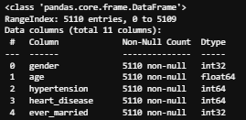
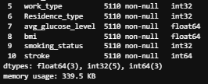

After label encoding each of the 10 fetaures are either in int values or float numbers.
- Data Partitioning: It is the process of dividing the available dataset into different subsets to train, validate, and test a machine learning model. It ensures that the model is evaluated on data it hasn't seen before and generalizes well to new, unseen data.
- Splitting the data for train and test
- x means the fetaures and Y means the target variable, 80% of data would be used for training and the 20% would be used for testing
- X ---X_train, X_test
- Y ---Y_train, Y_test

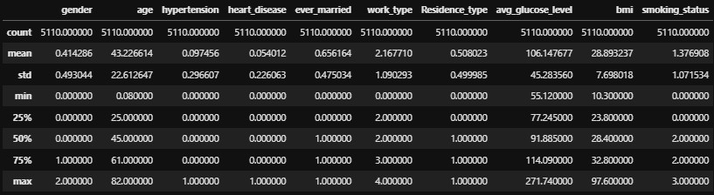
- Normalization: We need to scale down the data, in the dataset the mean between age and hypertension the distance was too large and hence the model will not be able to travel that much distance so it needed to be scaled down. The mean was scaled to zero and std to 1 so the data will be in a range.
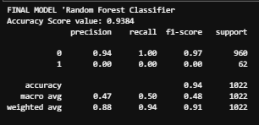
- Model Training – Model selection:
- The Machine learning models selected for this project were the Decision Tree, Logistic Regression, KNN, SVM and the Random Forest algorithms.
- 80% of data were used for the training phase and 20% of data were used for the testing phase.
- All of this 5 algorithms were trained and tested using the X_train, Y_train, X_test and Y_test. Y_pred was used to predict the results of X_test for each of the models.

- Model Evaluation:
This part contains the explanation of how experiments are been carried out and how findings are obtained throughout the research. This project was carried out with the aid of the python programming language, and machine learning and deep learning techniques were used to carry out this research. To start this project, I have used csv data, loaded the dataset in CSV format by using the methods in python and applied preprocess technique and applied all the machine learning classifier models and predicted the performance metrics for that dataset. The train, test split function is divided such that the train split contains 80% and test split contains 20% of data from the dataset. For the csv file I have used various algorithms in the machine learning classification such as the Decision tree , Knearest Neighbor , Logistic Regression, SVM and Random Forest algorithm.

Accuracy score generated by each of the five models:
Model Used | Accuracy Score
Decision Tree | 90.31
kNearest Neighbor | 93.44
Logistic Regression | 93.83
Random Forest | 93.84
SVM | 93.93

Bar graph representing the acccuracy score of each algorithm:
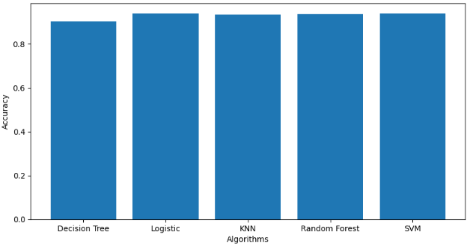

From the performance analysis of each algorithm we see that SVM , Random Forest and Logistic Regression has the top 3 best results with SVM achieving the highest accuracy slightly ahead of Random Forest. The model can help people with a cautionary indication of getting affected with stroke. The limitation of the steps was that the dataset used are not perfectly symmetrical. However it didn’t effect the accuracy of the algorithms.

- Model selection:
The Random Forest algorithm model was choosen as the base model to be integrated with the flask application. It returned 93.84% of accuracy and its test results indictaed that it accurately predicts and provides the result in the application.
The flask application was deployed into the localhost (port=5000). The homepage contains 10 features and input fields namely gender, age, hypertension, heart_disease, ever_married, work_type, Residence_type, avg_glucose_level, bmi, smoking_status and a button that is for to submit the input. On submission based on the input features and values the model predicts and informs whether the user is more likely to get a stroke or not.

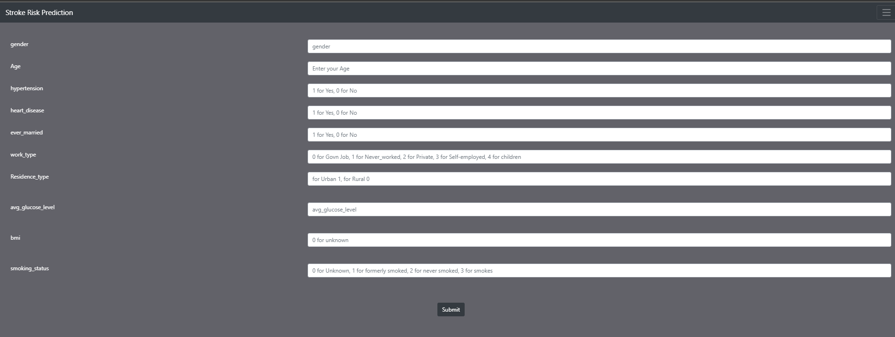
- App screenshots:
Fig. Home Page
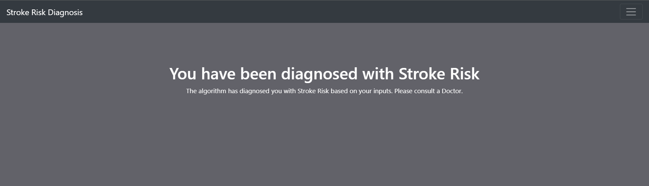
Fig. Model predicting the user is likely to get stroke
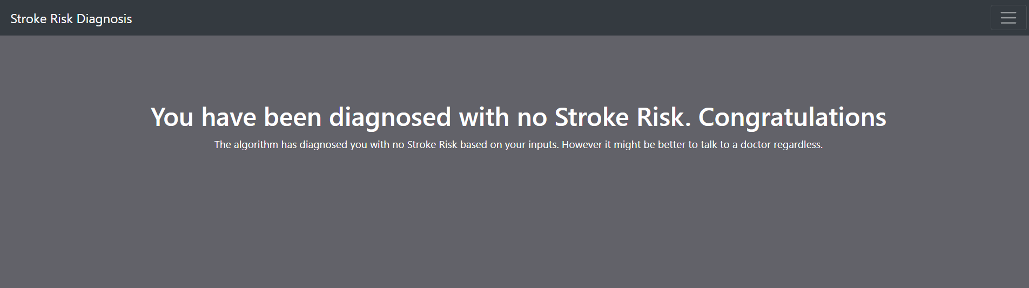
Fig. Model predicting the user is not prone to stroke risk

- CONCLUSION

Through this project a sufficently large dataset of stroke attacked patients has been successfully classified. Random Forest, Decision Tree, KNN, SVM and Logistic Regression were used for training and testing the model to detect stroke in patients. From the performance analysis we see that Random forest performed well to detect and proivde accurate results. The novelty and the main contribution of my project is collecting this dataset and preparing them to use with the application. The model can help people with a cautionary indication of being getting effected by stroke disease.
In future work, it is possible to extend the research by using different classification techniques and models to predict stroke disease more accurately by modiying this proposed model and improving its performance. Moreover to create a fully functioning hospital management system with login credentials for various users and various features pages will integrate this stroke detection feature within that application.

- ACKNOWLEDGEMENT

Special thanks to Mr. Manoj Singh for his exceptional support and guidance throughout this research. His insights and encouragement played a crucial role in shaping this work.

- REFERENCES

[1] D. Zhong, Y. Chen, Y. Chen, S. Ye, W. Cai, and M. Chen, “A Classification Method Based on Deep Convolutional Neural Network,” Journal of Healthcare Engineering, vol. 2021, 2021, doi: 10.1155/2021/7167891.
[2] T. M. Geethanjali, D. M. D, M. S. K, S. M. K, and A. Professor, “STROKE PREDICTION USING MACHINE LEARNING,” JETIR, 2021. [Online]. Available: www.jetir.orgd710
[3] B. Deepak Kumar, S. Yellaram, S. kothamasu, S. Puchakayala, and A. Professor, “Heart Stroke Prediction using Machine Learning,” 2021. [Online]. Available: www.ijcrt.org
[4] G. Sailasya and G. L. Aruna Kumari, “Analyzing the Performance of Stroke Prediction using ML Classification Algorithms.” [Online]. Available: www.ijacsa.thesai.org
[5] L. Amini, R. Azarpazhouh, M. T. Farzadfar, S. A. Mousavi, F. Jazaieri, F. Khorvash, R. Norouzi, and N. Toghianfar, “Prediction and control of heart stroke by data mining,” International Journal of Preventive Medicine, vol. 4, no. Suppl 2, pp. S245–249, May 2013.
[6] P. Govindarajan, R. K. Soundarapandian, A. H. Gandomi, R. Patan, P. Jayaraman, and R. Manikandan, “Classification of heart stroke disease using machine learning algorithms,” Neural Computing and Applications, vol. 32, no. 3, pp. 817–828, Feb. 2020.

